Representation within Video Games
The video game industry is a relatively interesting one as it has evolved faster than many other industries it can be compared to. For example, the Movie Industry has been around for a couple of centuries with the first motion pictures starting at the end of the 19th century. Videogames, however, are fairly recent, with the very first video game ever made being the game of ‘Pong’. A simplistic game where two players must bounce a ball back and forth between their sides. That being said, the video game industry has come a long way since its debut in the 1950s. With near photorealism being able to be captured, video game designers are able to put a whole lot more detail into their games.
With the ability to put more in a video game, comes the issue of representation. Genders and Religions are often the hardest to portray as there will always be some form of backlash from the public. Putting women in secondary roles will often attract feminist groups campaigning for women to have better representation in video games, often claiming video game designers to oversexualize females to appeal to the male fantasy. Moreover, placing religions will always be tricky as there could always be discrepancies with minor or even major plot points in certain religions simply due to lack of sources or accessibility.
Furthermore, video games are more accessible to the wider public thus have gained a lot of attention and time from the youth. This has led to more time being spent away from the outdoors and being placed in the bedrooms and living rooms of households. While there are specific and rare cases of crippling addictions caused by video games, these are often cherry picked examples by the media as they only choose to focus on the specific negatives.
This research paper aims to address the issues that the video game industry has to deal with in our modern society. Activists campaigning for different portrayals as well as stereotypes that a gamer face, all of these will be debunked throughout the presented research.
Table of Contents
Games and Religion 2 - 5
Games and Gender 6 - 10
Conclusion 10
Bibliography 11
Games and Religion
Religion is one of the hardest things to accurately portray. The very existence of religious groups outright contradicts the philosophies of other religions. Catholics, for example, believe that there is only one true omnipotent god with his son, Jesus, whilst there are other religions which believe there are multiple gods such as the Greek pantheon or Norse mythology.
The game I chose to focus on in particular is the video game ‘SMITE’. SMITE is a video game which places players in a Multiplayer Online Battle Arena (MOBA) style game where each player picks a character which they will fight the other players with. The characters that the players are allowed to select are Gods from multiple mythologies including the Greeks, Chinese, Hindu, and Norse.
The video game, SMTIE (Hi-Rez Studios, 2014), and its publishers, Hi-Rez Studios, have faced reasonable backlash from a whole plethora of communities, ranging from religious groups to activists, all complaining about the misrepresentation of the gods within the video games. Their claims are hard to oppress as they come from religious and sacred premises. Claims such as ‘Seeing gods from different religions socialize is a sin’, as well as ‘Gods portrayed in this video game aren’t how they would act as they would never use their omnipotent power for something as pointless as fighting other gods’ are particularly difficult to counter as they make sense under the principles that these religions have.
Thus, instead of analyzing such specifics of these gods, we shall be looking more on the surface of this video game, simply by answering the question: “Are the Gods that are in the videogame properly represented”. We will be answering this question by comparing the gods in the video game to sources of their existence in real life
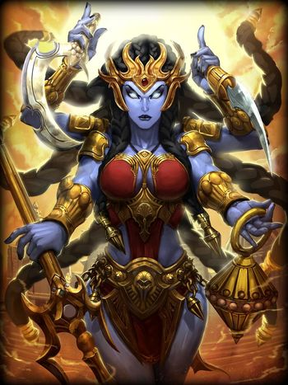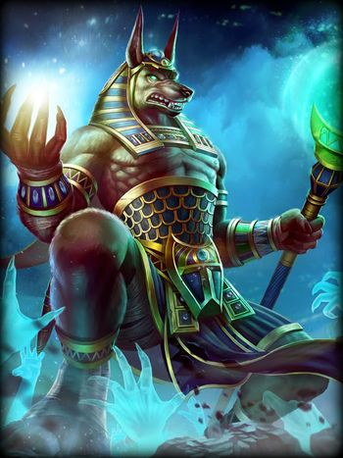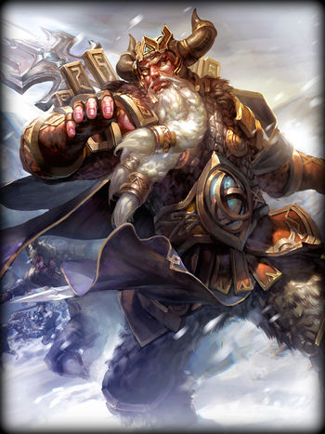
In the images above are three playable gods from the game. From left to right, Kali, Anubis, and Odin, from Hindu, Egyptian, and Norse religions respectively. I chose these three gods as they are some of the most commonly played characters in the game and they are also some of the most known gods from their religion. Anubis, the god of death, being references in multiple instances from movies to books. And Odin, Thor’s father, with the more recent interest in Norse mythology due to the MARVEL movies.
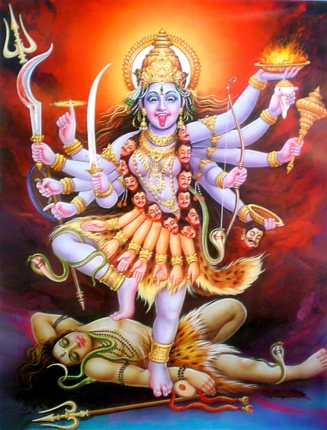
Kali
The picture on the left is a picture from the website Goddess. From first glance, we can already see how there are similarities and differences between the artistic portrayal of the goddess, and the video game portrayal. Basic similarities include the threatening nature of the woman through her trinkets and weapons, present in both pictures. Difference obviously lies within the style of representation as it is two different artists comparing the same source material. What’s interesting is that the artistic portrayal of the goddess is more graphic than the game. Her breasts and nipples are visible and she’s wearing a skirt made from hands and a necklace from heads, Whilst the game portrayal simply covers Kali’s body with a dress which covers those parts of her body more appropriately
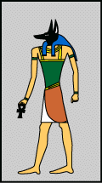
Anubis
Anubis’ portrayals are more plain as Egyptian gods’ original source materials were often represented through simple drawings and hieroglyphs. Anubis is referenced as a either a man with a jackal head, or a humanoid jackal. Generally, the portrayals are true to the source material, both for the video game and the image on the left. However, as stated in the introductory segment of this research paper. Anubis is not exactly portrayed as a fighter rather than a simple omnipotent figure who is in charge of his select duties. The video game portrays Anubis as more frightening with more power. While it could be argued either way, Anubis is a difficult one to analyze as Ancient Egyptian gods have less source materials as their religious practices are not practiced in today’s modern world.
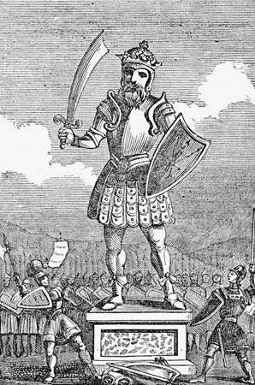
Odin
Unlike the previous two gods, Odin is considered to be a warrior and conqueror. The photo presented here clearly displays Odin’s militaristic value as an army of soldiers are shown to worship the deity. This misrepresentation simply falls under the ‘small inconveniences’ category where people complain about whether the portrayals are accurate or not. For example, In the picture from the game, Odin is shown wielding a spear while wearing a horned helmet and seemingly leather armor, whilst in the photo presented here, Odin is shown wearing metallic armor and wielding a sword and shield. These little discrepancies are not the most damaging, however, since they revolve around minor misrepresentations about groups that are commonly believed to be mythical thus no large groups or organizations full frontally complain about the misrepresentation of their religion.
Religion in itself is a rather tricky subject. It manifests in countless ways where loyalists will simply reject all forms of opposition as they believe that their religion is the one true religion. SMITE does a fair job avoiding the largely controversial groups such as the Abrahamic Religions, the Jewish, Christians, and Islam, as well as the Buddhists. Including these largely followed religions would surely create such a large controversy for the game that the game itself and the company would suffer. They have chosen to depict ancient religions as they are the least likely to be misrepresented, and this understanding can be applied to all video games choosing to depict religion

Games and Gender
Videogames and Gender has always been a controversial topic at heart. Especially within recent years due to the massive feminist movements, there have been a whole list of previously ignored video games that have received massive amounts of backlash for their portrayal of genders in video games. Moreover, the rise of the feminist movement as led to companies attempting to appease these activist groups by making females more empowered within their games, often making them main characters over their typical male companions. The problem with this is that there are the actual gamers who are less concerned about these issues and are more interested in the actual gameplay rather than the representation of gender roles.
For this segment of the paper I shall present some statistics which aid the argument that video games are unfairly portraying women in video games as well as display a few games and provide a logical analysis from both the point of view of the gamers and the activist groups as why people should or should not care about gender representation.
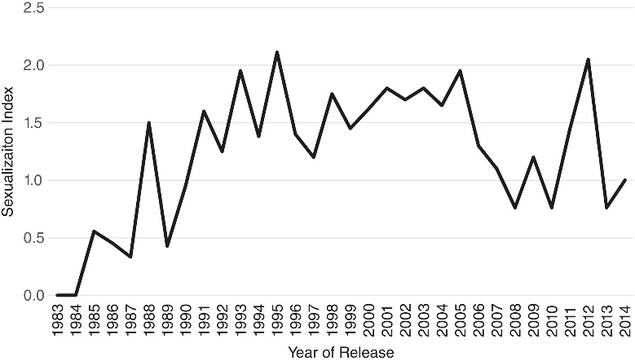
[Figure 1 (Left) – Graph showing sexualization of females in videogames throughout the years]
[Figure 2 (Right) - Graph showing female sexualization from Figure 1 in time blocks]
[Graphs obtained from https://onlinelibrary.wiley.com/doi/full/10.1111/jcom.12237#jcom12237-fig-0002]
As evident from Figure 1 and Figure 2, female sexualization has decreased within recent years yet was a clear rampant process during the early 2000s. Around that time, 3D processing technology has developed to a point where developers and game designers are able to create character models which look more realistic and human than ever before. This obviously led to artistic discrepancies between games where some games featured ‘normal’ looking women whilst others premiered ‘exotic’ women.
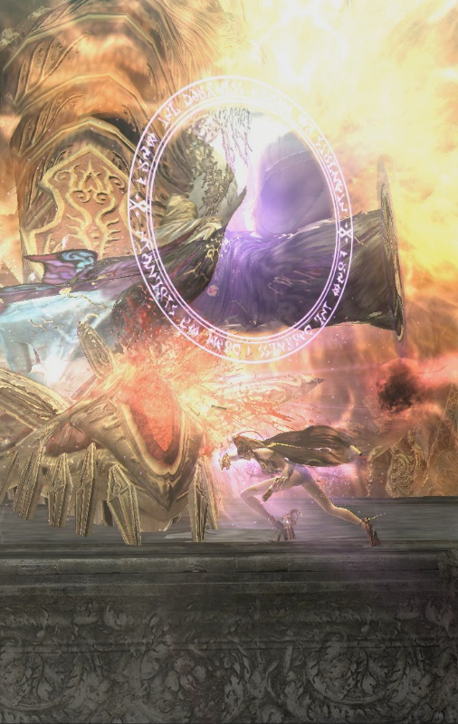
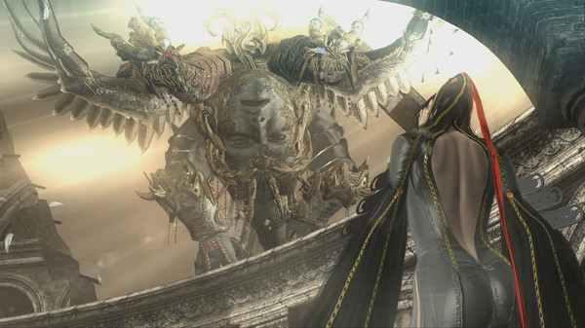
Bayonetta (Sega, 2009), a video game series created by Sega and published by Nintendo, is a prime example of this female sexualization. The image on the left is a screenshot from the video game where the protagonist, Bayonetta, is about to fight a powerful boss character. The plain appearance of Bayonetta is already questionable as most of her bare back is visible to the players. What’s even more questionable and even borderline misogynistic is the fact that Bayonetta, the protagonist which the players use throughout the game, uses magical attacks which revolve around using her hair. Moreover, it turns out that her hair is extremely long and easily manipulatable to the point where Bayonetta chooses to clothe herself with it. It is seen in many attack sequences that Bayonetta will use a large attack which will draw a lot of her power, and consequently, a lot of her clothing too. As we can see in the image on the right, the monster is being attacked by a large hair spike whilst it seems that Bayonetta is stripped bare. This game is a fair example of female over-sexualization and misrepresentation as it is simply irrational to attach such a sexual identity to a video game. While there is an explanation as to why her attacks require such as ridiculous method, it can also be argued that it is the developers fault for creating such smut and the publishers to allow the material to be publicly available. Bayonetta has spawned two sequels after its initial release in Japan in 2009 which indicate its success. This then sprouts the issue, would sexualization sell more video games? Clearly a question that a lot of developers will ask themselves as their primary audience is the male youth, but then they would be under attack by the female activists, rightfully, as they campaign for the marginalization of females in video games to cease.
However, submitting to the demands of the community in hopes of appeasing their rage is often not a good idea, especially when a company finds a unique formula that they can produce in their games. A prime example of this is the video game Star Wars Battlefront II.
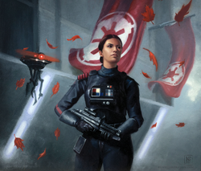
The video game, Star Wars Battlefront II, features a single player story mode where the player learns the story of the female commander, Iden Versio, as she aims to defect from the Empire. On the other hand, SWBII also offers a multiplayer experience where gamers play as soldiers in a major all-out war. The game sold fantastically, despite its initial controversies (Gilbert, A), however it was evident that people bought the game for the multiplayer experience and were genuinely disinterested in the single player experience and even reviewed it to be a bad single player campaign. While this isn’t the first single player experience that the company, Electronic Arts, have not succeeded in, its simple evidence that even in an attempt to appease the female activist groups by introducing a new female lead character that no one has ever heard of before, it simply won’t work when the gamers that purchase your games are simply interested in the gameplay rather than the story.
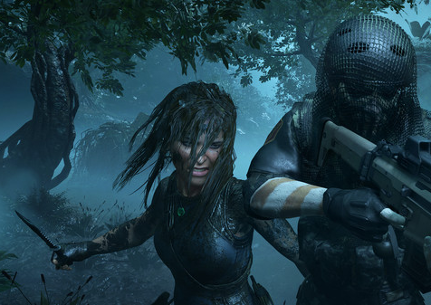
An example of a game that does correctly use the female lead role to their advantage is the Tomb Raider series. The Tomb Raider series takes from the already successful franchise of the Tomb Raider movies which portray a strong female character, Lara Croft, as an artifact and treasure hunter. However, the Tomb Raider series is another example of how people aren’t interested in the gender portrayals rather than the story and gameplay that the game companies can offer. A similar game series, Uncharted, shares a lot with the Tomb Raider series yet they’re considered two completely different games, not for the story, but for the way they play as games. As proven by the new Uncharted game which featured female character leads rather than the traditional male characters, their games did not sell any better or worse than their previous installments when they had a male lead.

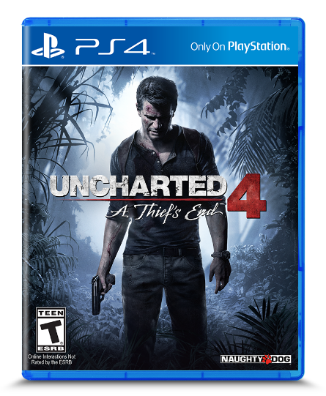
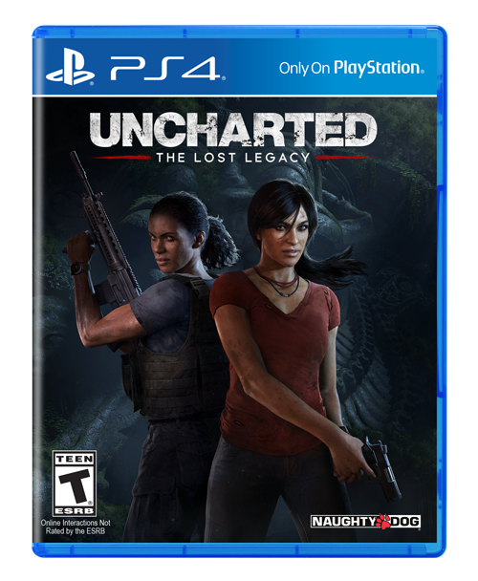
Uncharted 4 made $56 million in downloads while Uncharted Lost Legacy made top of the sales charts within the first week of its release

Conclusion
In conclusion, representation in a video game is important as it shows the basis of our society and what we are condoning and rejecting. It is the very premise as to why games that involve rape are often rejected as it is universally rejected, games that are often too bloody or graphic are also rejected due to controversy. Representation of both gender roles and religion is a new battlefield that video game companies have entered as they have previously operated without the need to be politically correct in the past. However, with more enlightened thinkers in society, we are able to spot out our flaws that are slowly changing the mindset of a particular group and call to action for change. For if we allow video games to remain misogynistic and only show females as objects, then we would be raising the wrong type of youth. However, there are those extremists that take representation as an opportunity to not be represented as equal, but to be represented above. Some feminist groups request that games with only female characters be released with no male characters or tropes. It is a very tough topic to target as there is a fine line in between not doing anything which would create abusive companies creating incorrect material which would alter the way we perceive other genders or religions, and then there’s the other side where we cave into the demands of all the extremist groups which would then lead to a terrible cesspool of demands where no single group can be sated.
Bibliography
- Games and Religion
SMITE, Titan Forged Studios, Hi-Rez Studios (2014). Microsoft Windows (https://www.smitegame.com/)
Kali. [Image]. Taken from https://smite.fandom.com/wiki/Smite_Wiki
Anubis. [Image]. Taken from https://smite.fandom.com/wiki/Smite_Wiki
Odin. [Image]. Taken from https://smite.fandom.com/wiki/Smite_Wiki
  - Kali
Kali. [Image]. Taken from http://www.goddess.ws/kali.html
  - Anubis
Anubis. [Image]. Taken from http://www.ancientegypt.co.uk/gods/explore/anubis.html
  - Odin
Odin. [Image]. Taken from https://www.britannica.com/topic/Odin-Norse-deity
Games and Gender
Graphs, Figure 1, Figure 2. [Images]. Taken from https://onlinelibrary.wiley.com/doi/full/10.1111/jcom.12237#jcom12237-fig-0002
Bayonetta, Nintendo, Sega (2009). https://www.platinumgames.com/games/bayonetta
Bayonetta. [Images]. Taken from https://store.steampowered.com/app/460790/Bayonetta/
Iden Versio. [Image]. Taken from https://starwars.fandom.com/wiki/Iden_Versio
‘Despite major controversy, the new ‘Star Wars’ game is a massive success’, Gilbert, B. Business Insider (2017). https://www.businessinsider.com/star-wars-battlefront-2-sales-november-2017-12
Lara Croft. [Image]. Taken from https://store.steampowered.com/app/750920/Shadow_of_the_Tomb_Raider/
Uncharted: The Lost Legacy, Uncharted 4: A Thief’s End. [Images]. Taken from www.unchartedthegame.com

